**MINOR PROJECT**

**Submitted by:** Vadde Sai Priya

**Project Name:** Employee Management with spring boot.

**Description:** In this minor project, we are demonstrating the operation for Employee Management like saving, deleting, updating and getting all the information of Employee.

**Technologies used:**

* Java
* Spring boot
* HTML
* CSS
* JQuery
* Ajax
* MySQL

**Procedure of the project:**

<http://localhost:9009/page>

1) The given link navigates to the dashboard with no data.

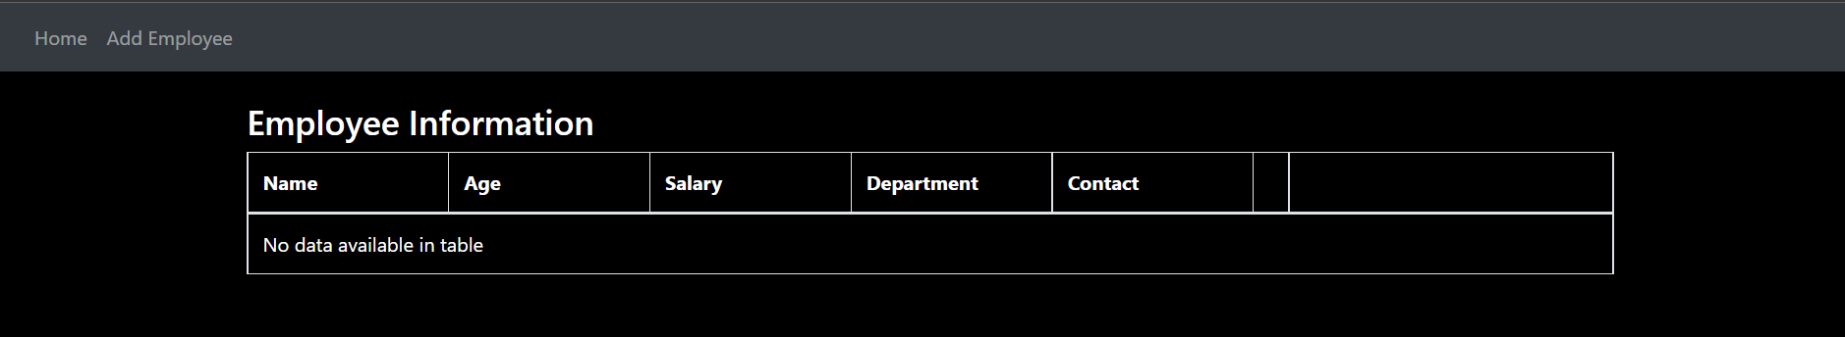

2) Click on ADD Employee to add information in the table.

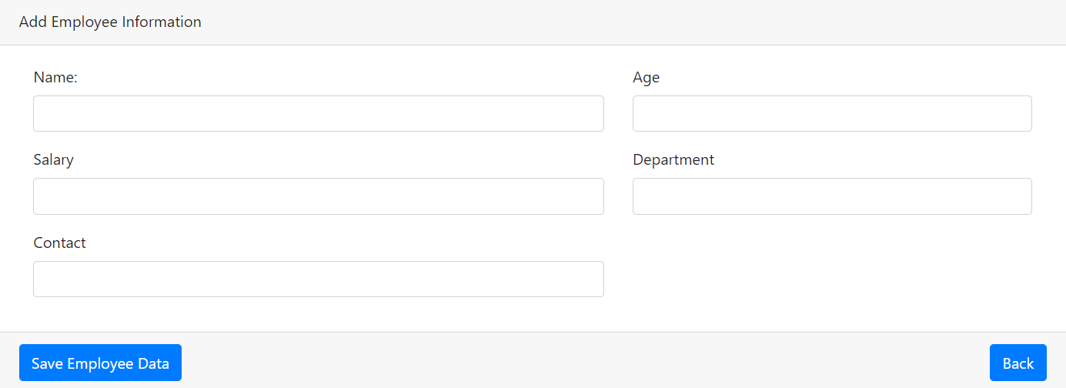

3) We can fill the information of a person here. After successfully filling up the data we get notification clearing that the information is successfully created.

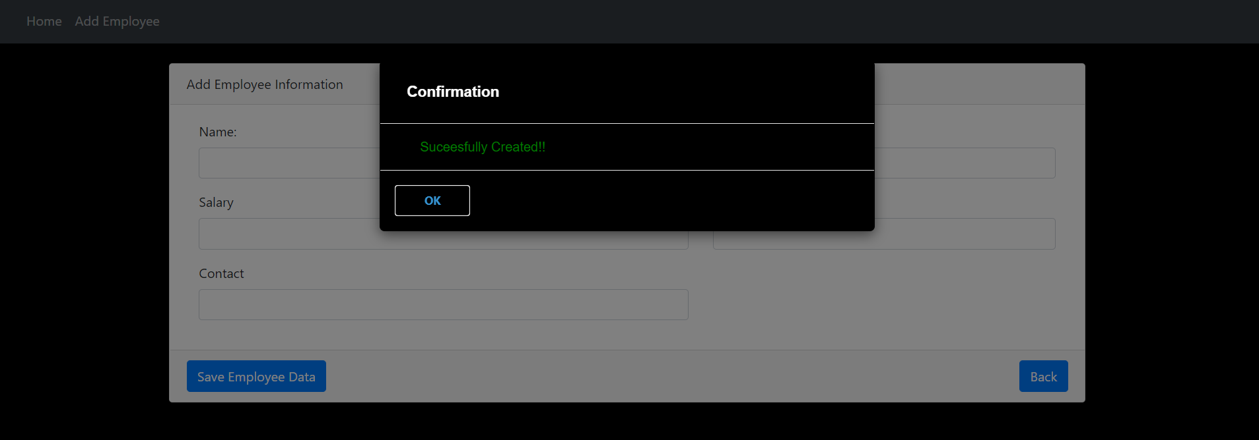

4) After the successful notification the created record will be shown in dashboard.

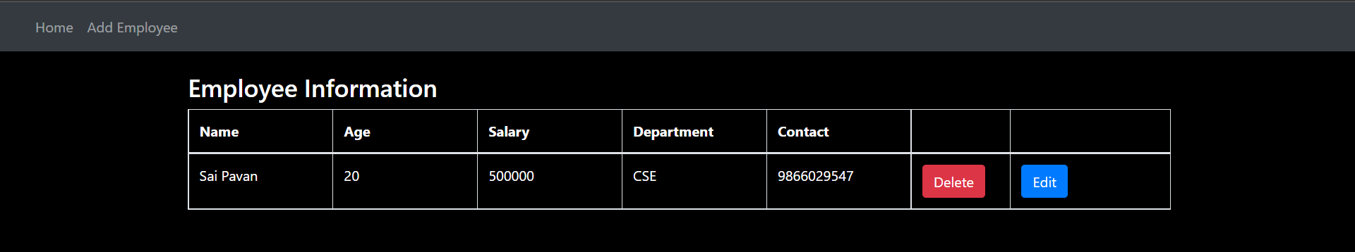5) If the data entered is wrong and we want to delete the data then we have delete button which deletes the data but before totally deleting it throws a notification specifying are u sure or not.

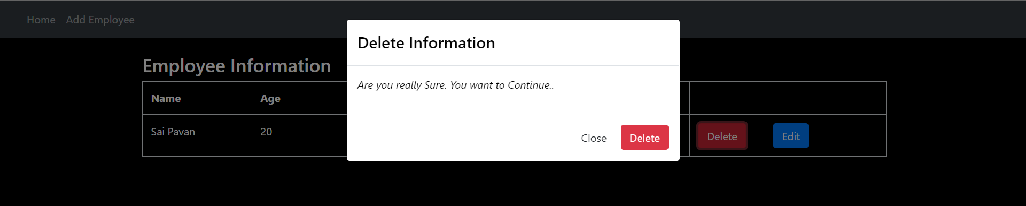

6) After deleting, the record will be cleared from the data permanently.

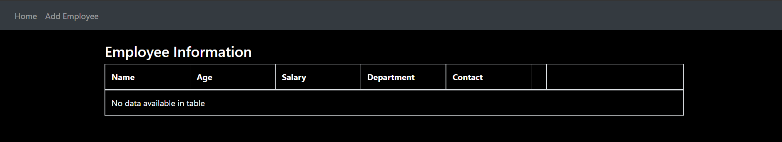

7) If a part of the data is to be updated then we use edit which can update the data.

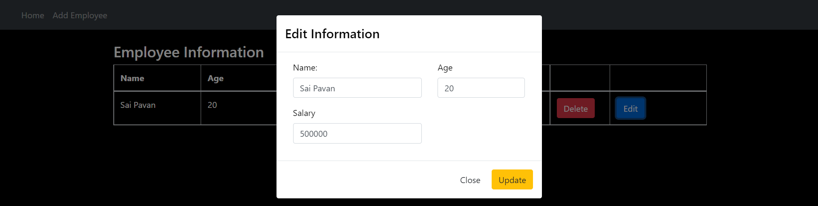

8) After updating the information in the record, the record will be also updated correspondingly.

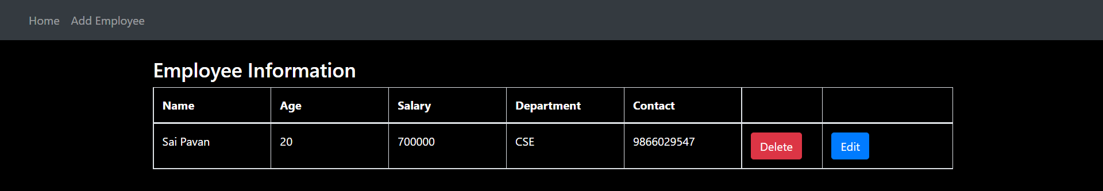

**Database tables:**  
create table employees_info (  
 emp_id integer not null auto_increment,  
 age integer,  
 contact bigint,  
 department varchar(255),  
 name varchar(255),  
 salary double precision,  
 primary key (emp_id)  
);  
  
  
--saving the Employee information  
  
insert into employees_info (  
 age, contact, department, name, salary  
)  
values  
 (?, ?, ?, ?, ?)  
  
 -- deleting the particular employee  
  
 delete from  
 employees_info  
 where  
 emp_id = ?

**Structure of the Project:**

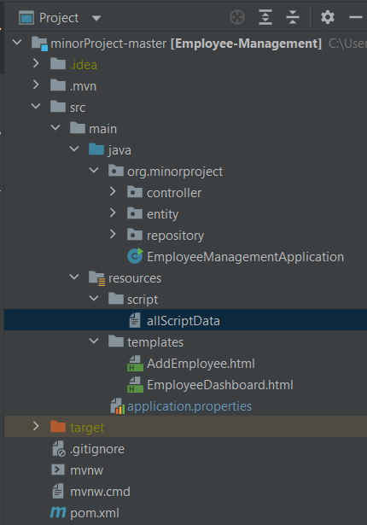

**Link to download the project:**

<https://github.com/saipriya14/Mini_Project>

**IDE used:**

* Eclipse
* STS
* Intellij

**Reference Websites:**

<https://www.w3schools.com/html/>

<https://getbootstrap.com/docs/4.0/getting-started/introduction/>

<https://start.spring.io/>

<https://spring.io/projects/spring-boot>